Technical Design Document

Project name: Wallet

* Saurav Suman(46022668)

**Introduction:**

Wallet is an application for XYZ Bank, where user can store money in wallet. This application allows customer to check balance, deposit money, withdraw money, fund transfer and show all transactions. There are 2 actors: Admin and Customer

**Functional Requirements:**

The functional requirements of the project are:

**For the Admin:**

* Delete User
* View Users
* Search User

**For the User:**

* Login/Register
* Deposit Money
* Withdraw Money
* Fund Transfer
* Show Balance
* Show all Transactions
* Edit Account Details

**Entity Relationship Diagram:**

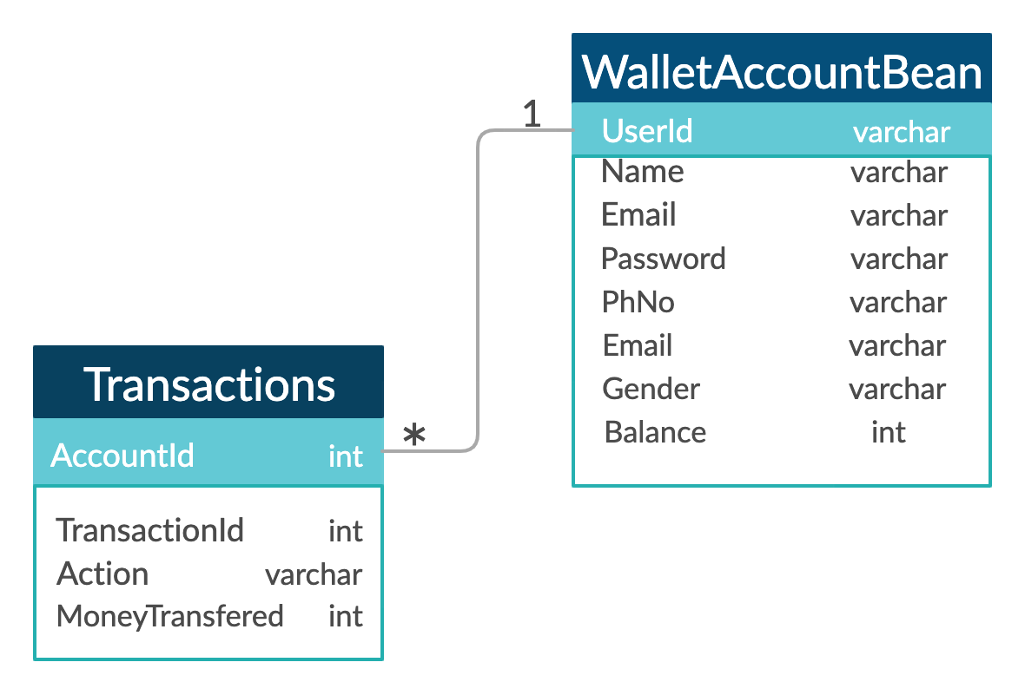

**Sequence Diagrams**

**Login -**

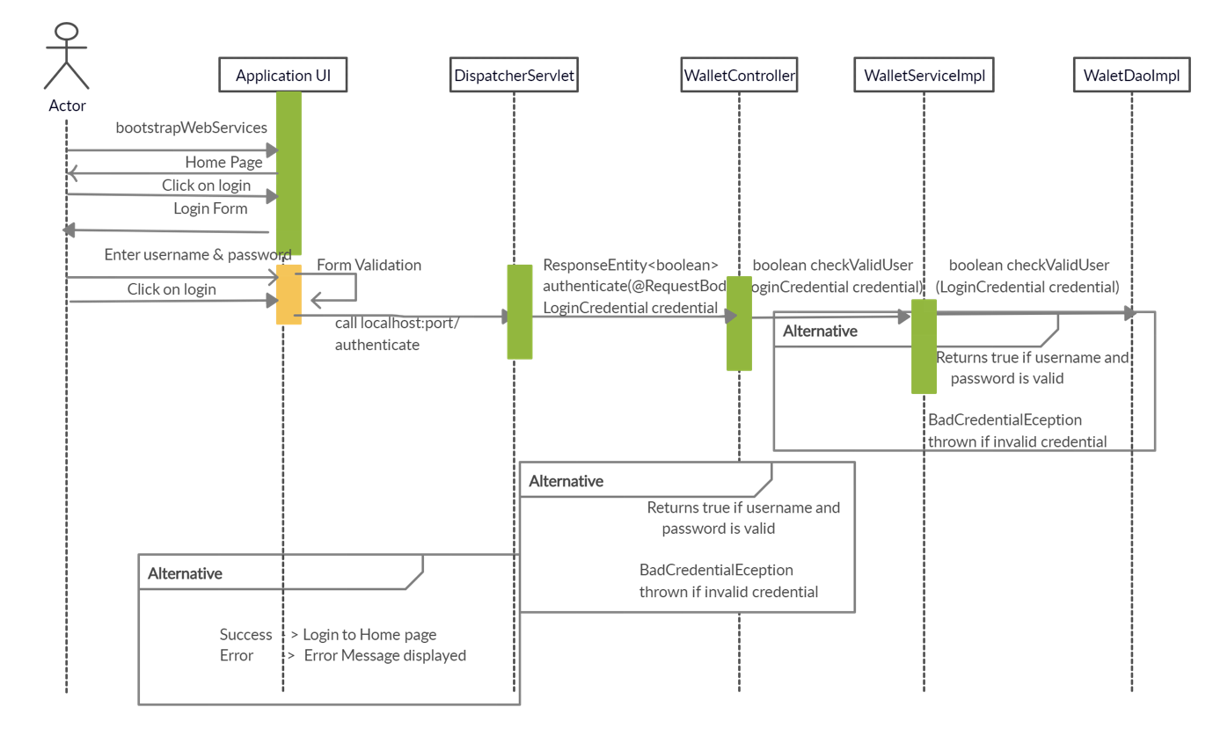

**Registration of new User -**

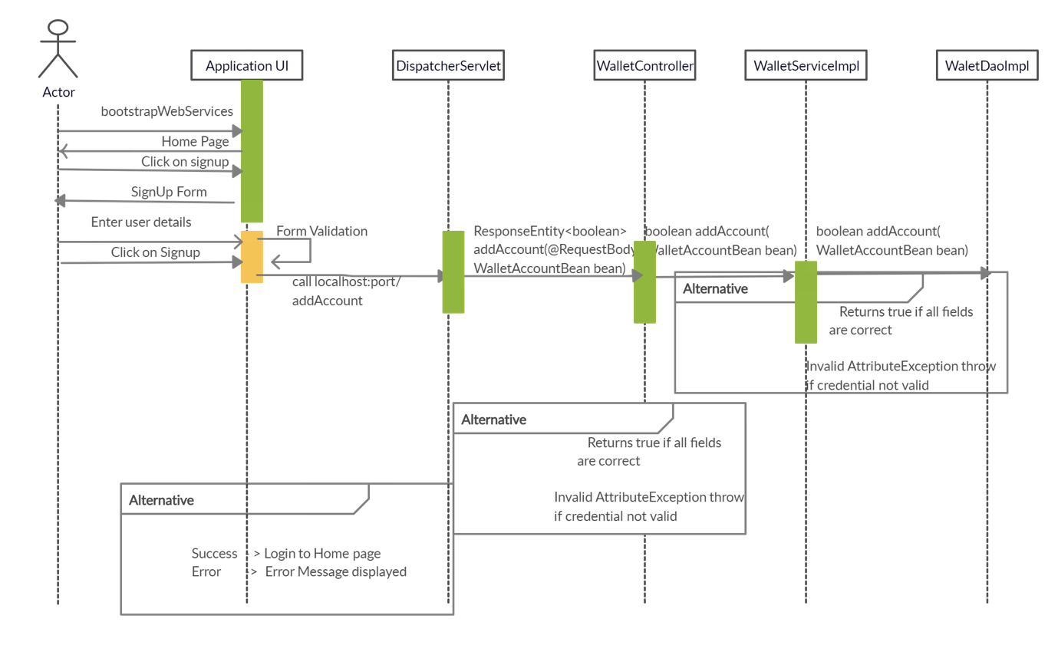

**Class Diagram**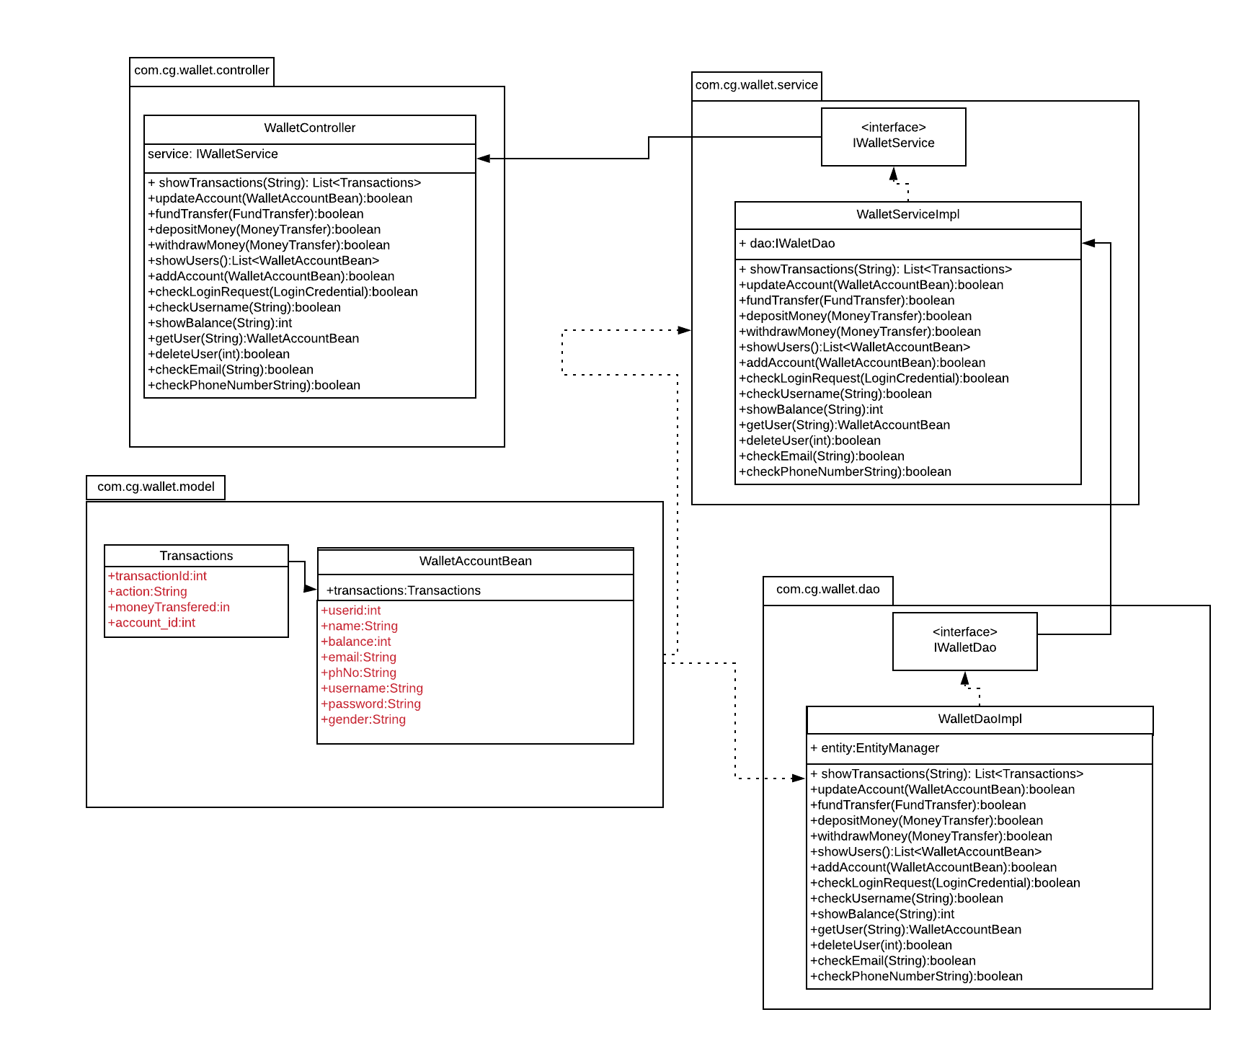

**Activity Diagrams**

**Login:**

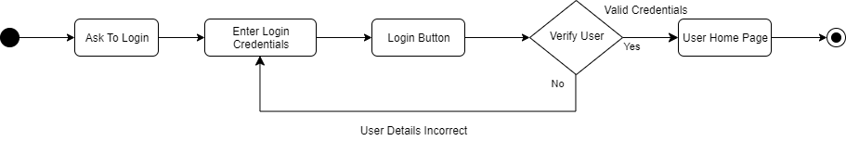

**Sign Up:**

**Logged in:**

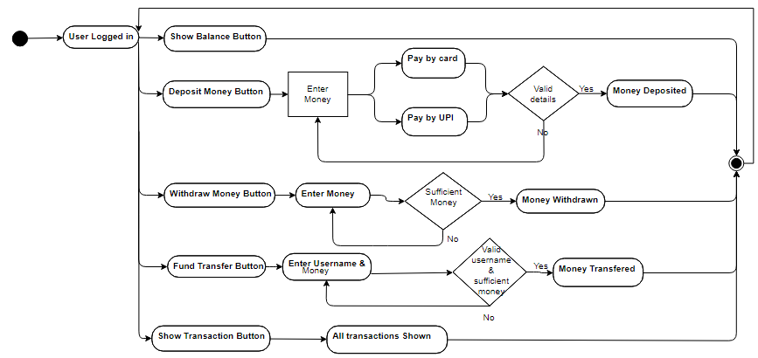

**Admin:**

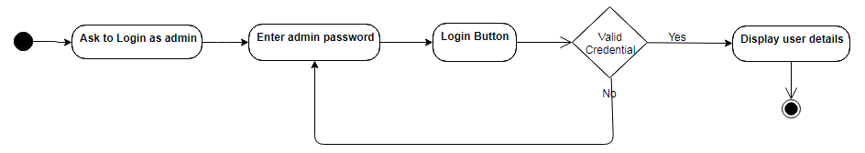

**Wireframes**

**Signup**

**Login**

**Logged In:- Show Balance**

**Logged In:- Withdraw Money**

**Logged In:- Fund Transfer**

**Logged In:- Deposit Money**

**Logged In:- Show All Transactions**

**Logged In:- View Account**

**Admin Panel**

